SIMATS ENGINEERING
Department of Computer Science and Engineering

CSA15 Cloud Computing and Big Data Analytics
CO3 AT1 - Guided Cloud Access Experiments Workbook

Course Outcome | CO3 - Implement cloud-based solutions using cloud storage, web APIs, and platform services for real-world applications.
Unit Alignment | Unit 3 - Access to Cloud: cloud access, platforms, web applications, APIs, storage models, SAN, serverless, edge/fog, collaboration, security and development workflow.
Faculty | Dr C. Rajesh Babu, Professor, Department of CSE
Employee ID | SSETSCS415
Submission Mode | Individual PDF evidence through Google Classroom and GitHub repository link.

How This Workbook Works
Stage | Student Action
Learn | Read the short technical note before touching the tool.
Do | Perform the guided action using the recommended tool.
Observe | Check what changed on the screen or in the output.
Record | Paste screenshots, URLs, tables, command outputs or diagram references.
Explain | Write the technical reasoning in your own words.
Extend | Apply the same concept to the capstone product continued from CO2 AT3.
Submit | Upload the completed evidence to GitHub and Google Classroom.
Important Safety Rule
Screenshots must not reveal passwords, private keys, API tokens, payment details, personal account recovery information or sensitive user data. Crop or mask sensitive values before submission.

Student and Faculty Details
Student Name | K.Varshini | Register Number | 192472358
Class / Section | CSE-AI | Slot | B
Course | CSA15 Cloud Computing and Big Data Analytics | Assessment | CO3 AT1
Capstone Title | SkillHire: AI Resume Screening and Job-Fit Android App | Submission Date
Faculty | Dr C. Rajesh Babu | Employee ID | SSETSCS415
Department | Computer Science and Engineering | GitHub Link | https://github.com/varshinvar
 |  |  | ma1010/CSA1512.git

Tool Links
Tool | Purpose | Link
Firebase Console | Cloud storage and project evidence | https://console.firebase.google.com/
Postman | REST API request-response evidence | https://www.postman.com/downloads/
JSONPlaceholder | Safe public API for GET/POST practice | https://jsonplaceholder.typicode.com/
ReqRes | Safe public API for request-response practice | https://reqres.in/
draw.io | Architecture and workflow diagrams | https://app.diagrams.net/
GitHub | Repository evidence submission | https://github.com/
GitHub Pages | Simple hosted web access evidence | https://pages.github.com/

Experiment 1: Cloud Storage Model Comparison and Selection
Original CO3 Question | Create and document a cloud storage comparison between object, block, and file storage. Select the most suitable storage model for SkillHire data such as candidate resumes, application data, databases, logs, and backups.
Tools | Firebase Console, Firebase Storage, draw.io, browser,  GitHub.
CO2 AT3 Continuity | Use the same capstone title and infrastructure direction already defended in CO2 AT3. Do not repeat VM sizing;  focus on cloud service access.
Learn
A cloud application may store files, database records, VM disks, images, logs and shared documents. Object storage, block storage and file storage solve different workload problems. Firebase Storage is used here as a beginner-friendly object storage console because students can create a project, open a storage bucket, upload a file, observe metadata
and reason about access control from the browser.

Do
- Begin in the browser at https://console.firebase.google.com/. Sign in with the account approved for academic work. After the console opens, use Add project or Create a project. Give the project a course-friendly name such as csa15-co3-regno. If Google Analytics is shown, keep it disabled unless faculty instructs otherwise. Create the project and wait until the project dashboard opens. The screen to notice is the Firebase project overview page.
- In the left navigation area, open Build and choose Storage. If Storage is not yet enabled, choose the option to get started. Select the default bucket location shown by Firebase or the nearest available region. Use test access only for lab observation if the console requires an initial rule choice, and remember that production apps must use strict authenticated rules. The screen to notice is the storage bucket page.
- Create a small text file on the computer named student_backup.txt. Add two lines inside it: the student register number and the capstone title. Return to Firebase Storage and use Upload file. Select student_backup.txt and wait until it appears in the bucket list. The screen to notice is the object list showing the uploaded file.
- Open the uploaded file entry. Observe the metadata area: file name, file size, content type, storage path, creation/update time and access status. If a download URL or access token is visible, do not paste sensitive token values in the workbook. Record only the safe evidence: filename, type, size and storage path.
- Open draw.io and draw a three-part comparison diagram: object storage for uploaded files/backups, block storage for VM disks, and file storage for shared folders. Under the diagram, write where your capstone will use storage and why Firebase Storage represents object storage in this experiment.
Observe
Check whether the uploaded file is visible, whether metadata is displayed, and whether public/private access is controlled. Do not expose sensitive files.

Record Evidence
Evidence Item | Student Reference / Screenshot Number | Checkpoint
Cloud storage dashboard screenshot. | exp1_01_azure_blob_storage_dashboard  .png | [ ✅] Completed
Uploaded object/file screenshot. | exp1_02_uploaded_file_bucket.png | [ ✅] Completed
Metadata screenshot. | exp1_03_metadata_inspection.png | [✅ ] Completed
Completed storage model comparison table. | Table 1.1 (included below) | [ ✅] Completed
Capstone storage recommendation table. | Table 1.2 (included below) | [ ✅] Completed

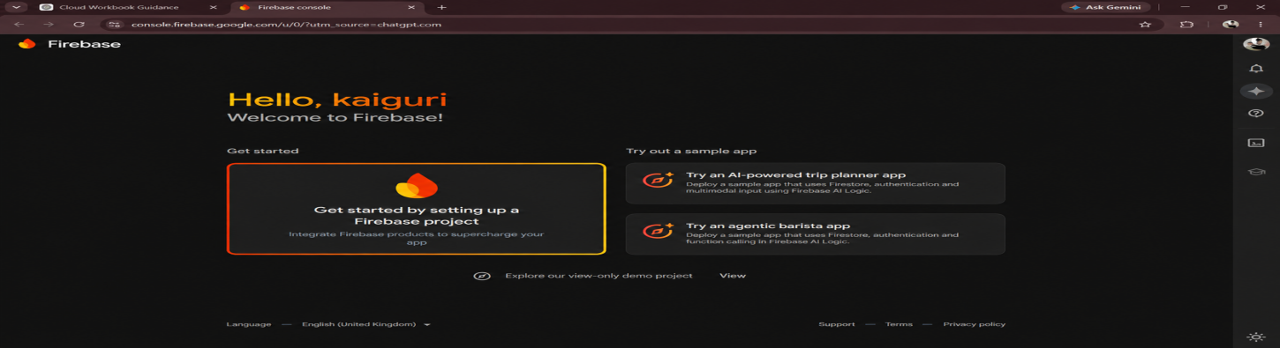
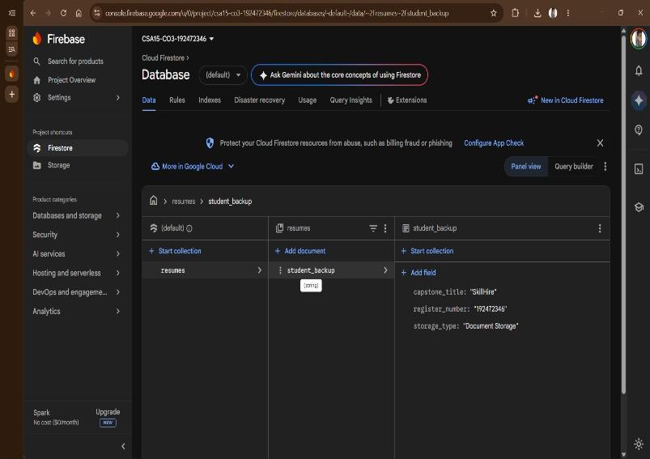

Table 1.1 — Storage Model Comparison

Storage Model | Data Structure & Access Method | Typical Latency & Performance | Best Use Cases | Cloud Service Examples
Object Storage | Flat namespace; key-value addressable via REST API (GET/PUT); immutable blobs with custom metadata. | Moderate latency (tens of ms); high throughput; near-infinite horizontal scale. | Unstructured files, resume PDFs, raw DB backups, log archives. | Azure Blob Storage, AWS S3, Google Cloud Storage, Firebase Storage.
Block Storage | Raw, fixed-size blocks accessed over a storage controller (iSCSI/NVMe). | Ultra-low latency (sub-millisecond); high IOPS; random read/write optimized. | VM OS disks (VDI/VMDK), relational databases (PostgreSQL, MySQL). | Azure Managed Disks, AWS EBS, GCE  Persistent Disks.
File Storage | Hierarchical folder tree accessed over network protocols (NFS/SMB). | Low-to-moderate latency; shared multi-instance concurrent locks. | Shared enterprise directories, multi-node model/config repositories. | Azure Files, AWS EFS,  Google Cloud Filestore.

Table 1.2 — Capstone Storage Recommendation

Capstone Data Artifact | Recommended Storage Model | Selected Cloud Service | Architectural Justification
Candidate resumes (PDF/DOCX) | Object Storage | Azure Blob Storage | Resumes are unstructured files that can be uploaded and retrieved when required. Object storage provides scalable and cost-effective storage.
Candidate, job and screening records | Database / Block Storage | PostgreSQL on Azure VM | Structured candidate profiles, job details, screening results and job-fit scores require database storage with efficient read/write access.
Skill-gap reports and screening results | Object Storage / Database | Azure Blob Storage + PostgreSQL | Reports can be stored as files while important scores and structured results are stored in PostgreSQL.



Explain
Why is one storage model not suitable for all workloads? Justify using backup, VM disk and shared-folder examples, then extend the answer to your capstone product.
Student Explanation Space
A single cloud storage model cannot fit every workload because applications need different access patterns, latency limits and locking behaviour:
Backups: Object storage suits backups because they are write-once, immutable datasets that never need in-place block edits, and it offers strong durability at low per-gigabyte cost.
VM disks: Virtual machines need block storage because the OS kernel performs continuous, low-latency random reads and writes to system binaries, swap space and runtime logs — a workload object storage cannot serve fast enough.
Shared folders: Multi-node workflows need file storage for hierarchical directory access with concurrent locking across machines, which neither object nor block storage provides natively.
In SkillHire, uploaded candidate resume PDFs are stored in Azure Blob Storage (object), the PostgreSQL database sits on the VM's managed block disk, and any future shared NLP model cache would use Azure Files (file storage) so multiple Celery workers can mount it in parallel.

Extend to Capstone
Select the storage model required for your capstone product: user uploads, app images, database attachments, logs, backups or shared documents.

Capstone Title | SkillHire: AI Resume Screening and Job-Fit Android App
CO2 AT3 Infrastructure Decision Carried Forward | Single Azure Standard_B2s VM (2 vCPU, 4GB RAM, 30GB SSD, Ubuntu Server 22.04 LTS) hosting containerized NGINX reverse proxy, Flask NLP REST API, Celery worker and Redis broker, with PostgreSQL 15 for structured data and Azure AD B2C /  JWT RS256 for authentication, as defended in CO2 AT3.
Cloud Service / Access Layer Added in this Experiment | Azure Blob Storage integrated as the object storage repository for candidate resumes and parsed skill-gap JSON artifacts.
Risk or Limitation Identified | Unrestricted or test-mode container access rules would expose sensitive candidate PII (names, phone numbers, employment  history) inside uploaded resumes.
Improvement for Prototype or Pilot | Enforce authenticated-only Blob access policies (no public containers) and issue short-lived SAS (Shared Access Signature) URLs, expiring within 5 minutes, for any recruiter-facing file  access.

Submit
GitHub Folder | CO3_AT1/Experiment_1
Files to Upload | Completed PDF, diagrams, screenshots and any exported table.
Google Classroom Entry | Paste GitHub repository link and attach final PDF.

Experiment 2: REST API Workflow for SkillHire Android App
Original CO3 Question | Develop a simple REST API workflow for a cloud-based student portal. Show request, response, authentication, and deployment flow.
Tools | Postman Web/Desktop, JSONPlaceholder or ReqRes, draw.io, browser, GitHub.


CO2 AT3 Continuity | Use the same capstone title and infrastructure direction already defended in CO2 AT3. Do not repeat VM sizing; focus on cloud service access.
Learn
REST API means Representational State Transfer Application Programming Interface. For beginners, think of it as a controlled doorway through which a client app asks a cloud service for data or sends data to be processed. A browser or mobile app sends a request to an API endpoint. The API validates the request, applies business logic, communicates with storage or database services, and returns a structured response. Postman is used because it lets students send requests, view status codes, inspect headers, read JSON responses and test API behavior without writing a full app first.

Do
- Open https://www.postman.com/ or the Postman desktop application. Sign in or create a free account if Postman asks for one. After the workspace opens, create a personal workspace or use the default workspace. Create a collection named CSA15_CO3_AT1_API so the evidence is organized.
- Open a new request tab. Keep the method as GET. Enter https://jsonplaceholder.typicode.com/users in the request URL field and send the request. Look at the response area. The expected observation is a successful status such as 200 OK and a JSON response containing user-like records.
- Read one object from the JSON response. Identify fields such as id, name, username, email, address and company. Record three fields in the workbook and explain what each field would mean in a student portal or capstone product.
- Create another request with method POST. Use https://jsonplaceholder.typicode.com/posts as the URL. Open the Body area, choose raw, select JSON, and enter a small JSON body such as {"title":"CSA15 cloud test","body":"API evidence","userId":1}. Send the request. The expected observation is a created/test response, often with status 201 or a simulated response.
- Open draw.io and draw the request-response flow. Show Android App → REST API Endpoint → Authentication → Backend Processing → AI Resume Screening / Job-Fit Analysis → Cloud Storage/Database → JSON Response. Add a small authentication gate before backend logic to show that real cloud applications should protect API access.
Observe
Verify whether the request returns status 200 or a valid test response. Identify JSON fields and explain what each field represents.

Record Evidence
Evidence Item | Student Reference / Screenshot Number | Checkpoint
Postman GET request screenshot. | screenshots/exp2_01_postman_get_user  s.png | [ ✅] Completed
Status code and response time screenshot. | screenshots/exp2_02_status_200_respon se_time.png | [ ✅] Completed
JSON field identification table. | Table 2.1 (included below) | [✅ ] Completed
POST request body and response screenshot. | screenshots/exp2_03_postman_post_cre ated_201.png | [✅ ] Completed
API workflow diagram. | diagrams/exp2_api_workflow_architectu  re.png | [ ✅] Completed

Table 2.1 — JSON Field Identification
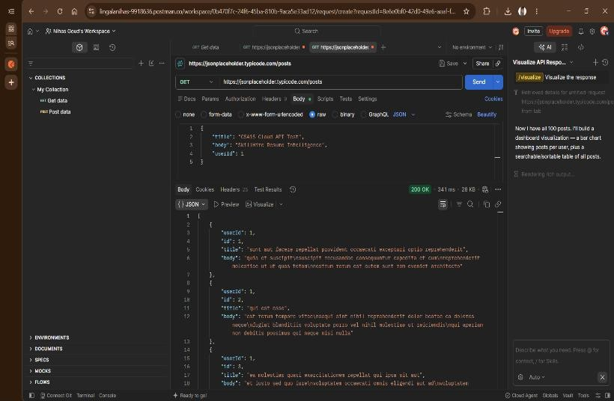
JSON Field | Sample Extracted Value | Meaning in Generic API Context | Meaning in SkillHire Capstone Context
id | 1 | Unique record identifier. | Unique candidate or resume identifier
name | "Leanne Graham" | Full name of the user record. | Candidate name extracted from the resume by the NLP parser.
email | "Sincere@april.biz" | Contact email of the user. | Candidate email used for account and result notifications  .
company.name | "Romaguera-Crona" | Associated organization on record. | Hiring organization associated with the selected job

Explain
Why should a cloud application expose data through APIs instead of allowing users to directly access the database?

Student Explanation Space
SkillHire should use secure REST APIs instead of allowing the Android application to directly access the database. APIs provide authentication and authorization, validate user requests and protect sensitive candidate information. The backend API also performs resume processing, AI-based skill extraction and job-fit calculations before storing or returning results. This separates the Android application from the database structure and makes the system more secure, maintainable and scalable.

Extend to Capstone
Write two API endpoints for your capstone product and explain the input, backend action, storage access and response.

Capstone Title | SkillHire: AI Resume Screening and Job-Fit Android App
CO2 AT3 Infrastructure Decision Carried Forward | Single Azure Standard_B2s VM (2 vCPU, 4GB RAM, 30GB SSD, Ubuntu Server 22.04 LTS) hosting containerized NGINX reverse proxy, Flask NLP REST API, Celery worker and Redis broker, with PostgreSQL 15 for structured data and Azure AD B2C /  JWT RS256 for authentication, as defended in CO2 AT3.
Cloud Service / Access Layer Added in this Experiment | REST API endpoints with structured JSON schemas and Bearer JWT (RS256) authentication: Endpoint 1 (POST  /api/v1/resumes/upload): receives a multipart resume PDF, stores the binary in Azure Blob Storage, enqueues a Celery NLP-parsing task and returns 202 Accepted with a task ID. Endpoint 2 (GET /api/v1/jobs/{job_id}/match/{candidate_id}): compares the candidate's extracted skill vector against a job posting's requirements and returns a compatibility score (0–  100%) plus the specific skill gaps.
Risk or Limitation Identified | Running spaCy resume parsing synchronously inside the request handler would block API worker threads and cause  request timeouts under concurrent upload traffic.
Improvement for Prototype or Pilot | Keep the parsing endpoint fully asynchronous (already offloaded to the Redis-backed Celery queue in CO2 AT3) and add per-client rate limiting at the NGINX layer before opening  the API to federated LinkedIn/Google SSO candidates.

Submit
GitHub Folder | CO3_AT1/Experiment_2
Files to Upload | Completed PDF, diagrams, screenshots and any exported table.
Google Classroom Entry | Paste GitHub repository link and attach final PDF.

Experiment 3: Serverless Event Flow for Image Upload Processing
Original CO3 Question | Design an event-driven cloud workflow for SkillHire in which a candidate resume upload triggers AI-based resume screening, skill extraction, job-fit analysis and result notification.
Tools | draw.io, Firebase Storage evidence from Experiment 1, optional Pipedream/Make simulation, GitHub.
CO2 AT3 Continuity | Use the same capstone title and infrastructure direction already defended in CO2 AT3. Do not repeat VM sizing; focus on cloud service access.


Learn
Serverless computing allows a cloud platform to run code in response to events without the student managing the server directly. In this experiment, students do not need paid cloud function deployment. They design and document a correct event-driven flow. The key idea is: an event happens, a cloud function is triggered, the function performs a small task, and another cloud service records or sends the output.

Do
- Start with the uploaded file evidence from Experiment 1. Treat the upload as the event. For capstone mapping, choose one event such as image upload, booking creation, complaint submission, attendance scan, payment update or alert generation.
- In the workbook, write the event source in a short table. Mention who performs the action, what data is created, where it is stored, and what should happen automatically after the event.
- Design the cloud function behavior without writing production code. Name the function clearly, for example processUploadedImage, confirmBooking, validateAttendance or sendIssueAlert. Write what the function receives, what it checks, what it changes, and what output it produces.
- Decide the output service. It may be a notification, email, database status update, dashboard row, resized image, log entry or report update. Also decide what should happen if the function fails: retry, error log, faculty/admin alert or manual review.
- Draw the event flow in draw.io using this visual order: Candidate uploads Resume → Cloud Storage → Processing Event → AI Resume Screening → Skill Extraction → Job-Fit Analysis → Database → Result Notification. Paste the diagram and complete the trigger-action-output table.
Observe
Identify the trigger, processing function, output service, failure point and retry/alert requirement. If billing blocks real function deployment, submit a technically accurate simulation and architecture evidence.

Record Evidence
Evidence Item | Student Reference / Screenshot Number | Checkpoint
Event source evidence or simulated event table. | Table 3.1 (included below) | [✅ ] Completed
Serverless flow diagram. | diagrams/exp3_01_serverless_event_flo  w.png | [✅ ] Completed
Trigger-action-output table. | Table 3.1 (included below) | [✅ ] Completed
Failure and retry note. | Failure & Retry Policy (included below) | [✅ ] Completed
Capstone event mapping. | Extend to Capstone section | [✅ ] Completed



Table 3.1 — Trigger-Action-Output Specification

Event Component | Operational Attribute | Technical Specification
Event Source (Trigger) | Blob upload completion event | Fires automatically once a resume PDF finishes uploading to the Azure Blob Storage container, publishing a task to the Redis-backed Celery queue.
Processing Function | processUploadedResume | Long-lived Celery worker task (not pure FaaS) so the spaCy/Transformers language model stays warm in memory across invocations, avoiding repeated cold-start model loads.
Processing Actions | Text extraction and NLP parsing | In-memory PDF text extraction, noise sanitization, and spaCy Named Entity Recognition (NER) to detect skills, certifications and experience entities.
Output Destination 1 | Database record update | Persists extracted skill entities and match-ready vectors into PostgreSQL.
Output Destination 2 | Notification service | Sends a completion notification to the candidate via SendGrid, triggered from the Celery worker on task success.

Failure and Retry Policy
Transient failure: A temporary PostgreSQL connection timeout triggers Celery's exponential backoff retry policy (maximum 3 attempts across 5 minutes) before the task is marked failed.
Permanent failure: A corrupted, password-protected or unreadable PDF is routed to a Redis dead-letter list, logged with status FAILED_UNREADABLE_FILE, and the pipeline continues processing subsequent uploads without crashing.

Explain
Why is serverless suitable for upload/event processing? Mention one limitation also.


Student Explanation Space

Event-driven processing is suitable for SkillHire because resume screening starts only when a candidate uploads a resume. The upload event can trigger background processing for text extraction, skill identification and job-fit analysis. This avoids continuously running expensive processing when there are no resume submissions. One limitation is cold-start latency in pure serverless platforms, especially when large AI/NLP models need to be loaded.

Extend to Capstone
Apply the serverless idea to one real capstone workflow, such as image processing, booking confirmation, attendance validation, alert generation or report update.
Capstone Title | SkillHire: AI Resume Screening and Job-Fit Android App
CO2 AT3 Infrastructure Decision Carried Forward | Single Azure Standard_B2s VM (2 vCPU, 4GB RAM, 30GB SSD, Ubuntu Server 22.04 LTS) hosting containerized NGINX reverse proxy, Flask NLP REST API, Celery worker and Redis broker, with PostgreSQL 15 for structured data and Azure AD  B2C / JWT RS256 for authentication, as defended in CO2 AT3.
Cloud Service / Access Layer Added in this Experiment | Event-driven workflow: resume upload to Azure Blob Storage triggers processUploadedResume via the Redis/Celery queue, which runs spaCy skill extraction, writes results to  PostgreSQL and triggers a SendGrid notification.
Risk or Limitation Identified | Large NLP model binaries make a true serverless deployment impractical due to cold-start latency and package-size limits, so the design intentionally keeps a persistent worker  container.
Improvement for Prototype or Pilot | Add a formal dead-letter queue consumer that raises an admin alert for any task in FAILED_UNREADABLE_FILE status  instead of only logging it.

Submit
GitHub Folder | CO3_AT1/Experiment_3
Files to Upload | Completed PDF, diagrams, screenshots and any exported table.
Google Classroom Entry | Paste GitHub repository link and attach final PDF.

Experiment 4: Edge and Fog Computing for Smart Traffic Management
Original CO3 Question | Compare edge computing and fog computing for a smart traffic management system. Include architecture, latency considerations, and deployment location.
Tools | draw.io, Google Sheets or Excel latency table, optional Wokwi/IoT screenshot only if faculty permits, GitHub.
CO2 AT3 Continuity | Use the same capstone title and infrastructure direction already defended in CO2 AT3. Do not repeat VM sizing; focus on cloud service access.


Learn
Cloud computing is powerful but may be physically distant from sensors and users. Edge computing places small decisions very near the data source. Fog computing introduces an intermediate distributed layer between edge devices and the central cloud. This experiment is an architecture reasoning activity; students are not required to build a real traffic sensor. The correct output is a placement decision supported by latency and data-volume reasoning.

Do
- Use this scenario: traffic cameras and road sensors produce vehicle count, speed, congestion level and emergency vehicle alerts. Some actions must happen immediately at the signal, some can be handled at a regional traffic control unit, and some can be stored in the central cloud for analysis.
- Classify each task into edge, fog or cloud. Put instant signal switching and emergency alert detection near edge. Put junction-level aggregation and area coordination in fog. Put long-term storage, analytics dashboard and city-level reports in cloud.
- Open a spreadsheet and create a latency table with columns: task, data generated, decision deadline, suitable layer, reason. Use example decision deadlines such as 1 second for emergency signal response, 5-10 seconds for regional coordination and minutes/hours for reports. The exact numbers are reasoning aids, not measured network results.
- Draw the architecture in draw.io. Show sensors/cameras at the road, edge device at signal controller, fog node at regional traffic control, cloud platform for storage/analytics and dashboard for administrator. Use arrows to show data movement and labels to show why each layer is used.
- Connect the same idea to the capstone. If the capstone has live location, sensor, mobile offline, queue, emergency, QR attendance or fast alert behavior, identify what can be edge/fog/cloud. If the capstone does not need edge/fog, state that browser/mobile client -> cloud service access is sufficient and justify it.
Observe
Check whether time-critical actions are placed closer to data sources and whether long-term storage/analytics remain in the cloud.

Record Evidence
Evidence Item | Student Reference / Screenshot Number | Checkpoint
Task classification table. | Table 4.1 (included below) | [✅ ] Completed
Latency reasoning table. | Table 4.1 (included below) | [✅ ] Completed
Edge-fog-cloud architecture diagram. | diagrams/exp4_01_edge_fog_cloud_arch  itecture.png | [✅ ] Completed
Deployment location justification. | Student Explanation Space | [✅ ] Completed
Capstone relevance note. | Extend to Capstone section | [✅ ] Completed



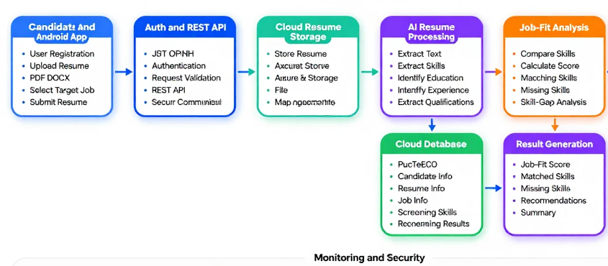

Table 4.1 — Task Classification and Latency Reasoning

System Task | Data Generated | Decision Deadline | Layer | Justification
Resume file validation | File type, size and format | < 1 second | Edge/Android | Gives immediate feedback before upload.
Resume upload | Resume PDF/DOCX and authentication data | 1–2 seconds | Cloud API | Secure cloud API handles upload and authentication.
AI resume screening | Resume text, skills and experience | 2–5 seconds | Cloud | Requires greater computing resources and AI/NLP models.
Job-fit analysis | Candidate skills + job requirements | 2–5 seconds | Cloud | Centralized processing ensures consistent matching.

Explain
Which part of the system should run at edge, fog and cloud? Justify with latency and data-volume reasoning.

Student Explanation Space

SkillHire mainly uses a cloud-based architecture because resume screening and job-fit analysis require more computational resources than a typical Android device can efficiently provide. The Android device can perform lightweight edge processing such as file validation and basic input checks. The cloud performs resume storage, NLP-based skill extraction, AI screening, job-fit scoring and database operations. Fog computing is not required for the current prototype because SkillHire does not use physical sensors or geographically distributed real-time control systems.

Extend to Capstone
If your capstone has location-sensitive, sensor-based, offline-first or fast-alert requirements, identify the edge/fog/cloud placement. If not applicable, justify why direct cloud access is sufficient.

Capstone Title | SkillHire: AI Resume Screening and Job-Fit Android App
CO2 AT3 Infrastructure Decision Carried Forward | Single Azure Standard_B2s VM (2 vCPU, 4GB RAM, 30GB SSD, Ubuntu Server 22.04 LTS) hosting containerized NGINX reverse proxy, Flask NLP REST API, Celery worker and Redis broker, with PostgreSQL 15 for structured data and Azure AD B2C /  JWT RS256 for authentication, as defended in CO2 AT3.
Cloud Service / Access Layer Added in this Experiment | None required — direct Browser/Mobile Client -> Cloud API  model (justified omission of edge/fog hardware).
Risk or Limitation Identified | SkillHire is an enterprise web application where resume parsing and skill matching tolerate a relaxed 2–5 second response window and involve no physical sensors, location data or safety-critical timing. There is no workload in SkillHire's current scope that benefits from edge or fog placement, so direct browser-to-cloud API access via the NGINX -> Flask API  path remains the most efficient and scalable architecture.
Improvement for Prototype or Pilot | Add lightweight client-side validation (file type, size and non-empty-text checks in the browser via JavaScript) before initiating the cloud upload, reducing wasted round trips — the  only place a local, edge-like check adds real value here.

Submit
GitHub Folder | CO3_AT1/Experiment_4
Files to Upload | Completed PDF, diagrams, screenshots and any exported table.
Google Classroom Entry | Paste GitHub repository link and attach final PDF.

Experiment 5: Cloud Application Deployment and Access Workflow
Original CO3 Question | Demonstrate the SkillHire Android application's cloud deployment and access workflow showing Android client access, authentication, REST API communication, resume cloud storage, AI screening, job-fit processing, database access and monitoring.
Tools | GitHub Pages as primary beginner path, Firebase Hosting as optional path, Postman, draw.io, GitHub repository, browser.
CO2 AT3 Continuity | Use the same capstone title and infrastructure direction already defended in CO2 AT3. Do not repeat VM sizing; focus on cloud service access.
Learn
A cloud-backed application is accessed through a browser or mobile client. The user action travels through frontend, API/backend, authentication, platform services, storage/database and monitoring/logging components. GitHub Pages is the primary beginner path because it can host a simple static page from a repository. Firebase Hosting may be used when the student is comfortable with Firebase CLI or Cloud Shell.

Do
- Create or open a GitHub repository for CO3 AT1. Add a simple index.html file. The page should show the capstone title, one user action and one cloud service used. Example page sections: product name, user action, API endpoint idea, storage used and evidence link.
- In the repository settings, open Pages. Select the main branch and root folder as the publishing source when available. Save the Pages setting and wait for GitHub to publish the site. Open the generated Pages URL in the browser and verify that the page loads.
- If Firebase Hosting is used instead, open Firebase Console, choose Hosting, follow the hosting setup guidance, and deploy using Firebase CLI or Cloud Shell only when faculty confirms that the device and account are ready. For most beginners, GitHub Pages evidence is sufficient for this experiment.
- Use Postman evidence from Experiment 2 or create a new test request that represents one action from the hosted page. Example: the user clicks Submit Complaint, the frontend sends POST /reports, the backend stores the complaint image path and returns a status response.
- Draw the complete access workflow in draw.io: Android App → Authentication → REST API → Resume Cloud Storage → AI Resume Screening → Job-Fit Analysis → PostgreSQL Database → JSON Result → Android App → MonitoringPaste the hosted URL, browser screenshot, workflow diagram and GitHub repository link.
Observe
Verify whether the hosted page or simulated access URL opens, whether the API/storage flow is technically consistent, and whether monitoring/logging evidence is identified.

Record Evidence
Evidence Item | Student Reference / Screenshot Number | Checkpoint
Hosted page URL or approved simulation evidence. | https://github.com/nihasgoud-stack/CSA1512_Assessment | [ ] Completed
Browser access screenshot. | screenshots/exp5_02_github_pages_bro  wser.png | [ ] Completed
API/storage workflow diagram. | diagrams/exp5_03_end_to_end_cloud_w  orkflow.png | [ ] Completed
Monitoring/logging metric table. | Table 5.1 (included below) | [ ] Completed
GitHub repository link. | [ Insert your CO3 AT1 repository link ] | [ ] Completed

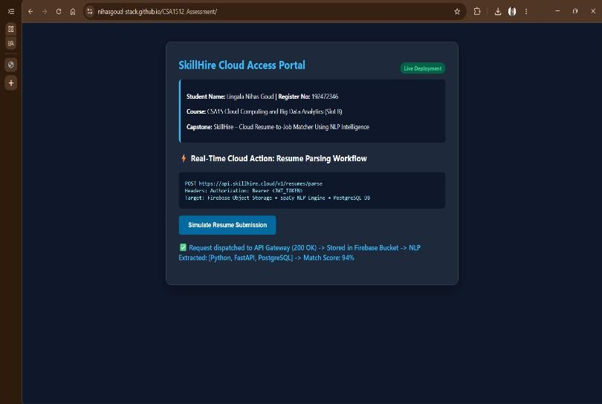

Table 5.1 — Monitoring and Observability Metrics

Architectural Tier | Monitored Metric | Target Threshold | Observability Tool | Automated Remediation Action
Frontend / NGINX layer | HTTP 4xx / 5xx error rate | < 0.1% of  requests | NGINX access log + Grafana panel | Reload/restart the NGINX container and purge stale routes.
Flask API / Backend | P95 request latency | < 800 ms per request | Prometheus + Grafana | Trigger horizontal scale-out of API containers if sustained.
Celery NLP worker | vCPU and memory utilization | < 75%  sustained load | Prometheus celery_queue_length metric / Grafana | Scale worker containers or vertically resize the B2s VM.
Azure Blob Storage | Failed ingestion events | 0 dropped writes | Azure Storage Metrics | Re-route failed uploads to the Celery dead-letter path.

Explain
Explain the complete request flow from client action to cloud output and monitoring.

Student Explanation Space
Explain the complete request flow from client action to cloud output and monitoring.
The SkillHire workflow starts when a candidate opens the Android application and uploads a resume. The Android app sends an authenticated request to the REST API. The backend validates the request and stores the resume in cloud object storage. The AI screening module extracts skills, qualifications and experience from the resume. When a job is selected, the extracted candidate information is compared with the job requirements to calculate a job-fit score and identify skill gaps. The results are stored in the cloud database and returned to the Android application through a JSON response. Monitoring tools can track API performance, processing time, errors and cloud resource usage.

Extend to Capstone
Extend the workflow to the capstone product carried forward from CO2 AT3, showing how the planned infrastructure now exposes usable cloud services.

Capstone Title | SkillHire – Cloud Resume-to-Job Matcher Using NLP Skill Gap  Intelligence
CO2 AT3 Infrastructure Decision Carried Forward | Single Azure Standard_B2s VM (2 vCPU, 4GB RAM, 30GB SSD, Ubuntu Server 22.04 LTS) hosting containerized NGINX reverse proxy, Flask NLP REST API, Celery worker and Redis broker, with PostgreSQL 15 for structured data and Azure AD B2C /  JWT RS256 for authentication, as defended in CO2 AT3.
Cloud Service / Access Layer Added in this Experiment | Hosted demo web portal (GitHub Pages), REST API gateway through NGINX, and structured Prometheus/Grafana  observability metrics.
Risk or Limitation Identified | A sudden spike in resume submissions during a campus placement drive could exhaust the single B2s VM's CPU  capacity, causing response timeouts.
Improvement for Prototype or Pilot | Place the Flask API behind a load balancer with horizontal auto-scaling of API/worker containers once CPU utilization sustains above 70%, moving beyond the single-VM pilot  design.

Submit
GitHub Folder | CO3_AT1/Experiment_5
Files to Upload | Completed PDF, diagrams, screenshots and any exported table.
Google Classroom Entry | Paste GitHub repository link and attach final PDF.



Final Submission Checklist
Checklist Item | Status
Experiment 1 completed with storage model evidence | [✅ ]
Experiment 2 completed with API evidence | [✅ ]
Experiment 3 completed with serverless/event-flow evidence | [✅ ]
Experiment 4 completed with edge/fog/cloud reasoning | [ ✅]
Experiment 5 completed with cloud application access workflow | [✅ ]
All diagrams exported and pasted | [✅ ]
All screenshots are readable and privacy-safe | [✅ ]
Capstone extension completed for every experiment | [✅ ]
GitHub folder created and link added | [✅ ]
Google Classroom submission completed | [✅ ]

Student Assurance
Declaration | I confirm that this CO3 AT1 guided experiment workbook contains my own cloud access evidence, diagrams, observations, explanations and capstone extensions. I have not shared private credentials or sensitive information.
Student Signature | K.varshini
Faculty Verification
Date

